Exp. No: 2
Determination and plotting of Electric field and Electric flux density in sphere full of charges with varying radius.

Aim:
To write program for electric field and electric flux density in sphere using SCILAB.

Software required:
•SCILAB version 6.0.1

Program:
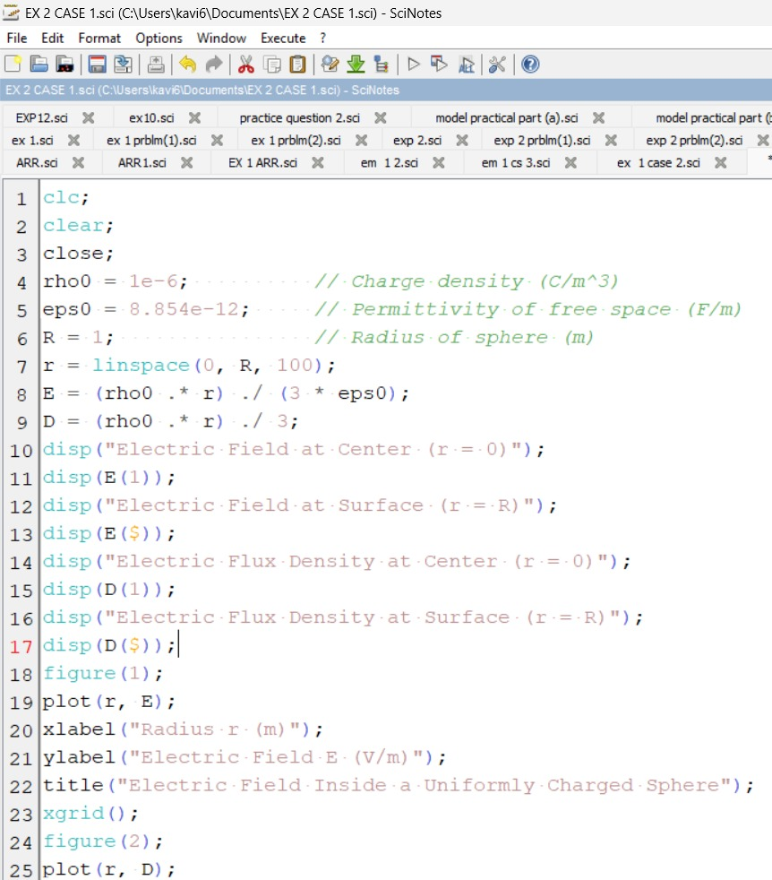
Output:-

Enter the value of q=2*10^-6
Enter the value of r=6*10^-3
"The electric field is"
5.004D-16
"The flux density is"
4.431D-27

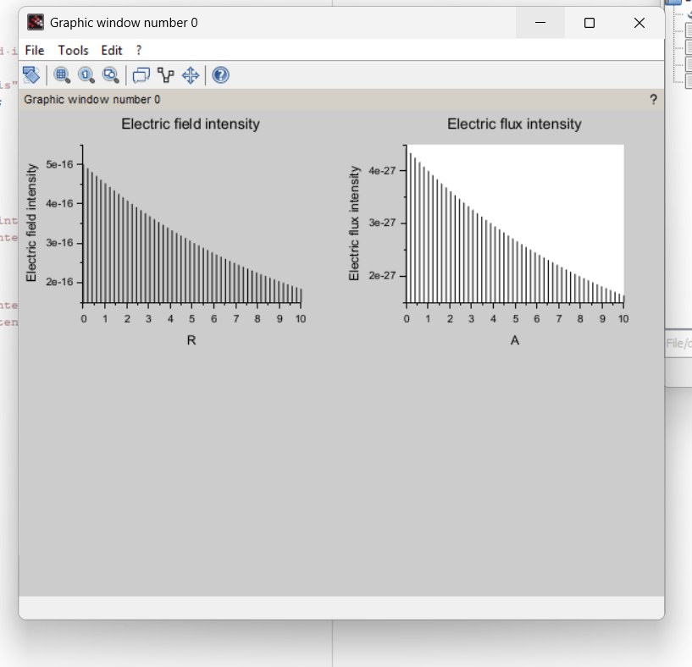Case 1:
Derive and plot the electric field (E) and electric flux density (D) inside a uniformly charged sphere with charge density ρ0. What are the values of E and D at the center and at the surface of the sphere?
Code:
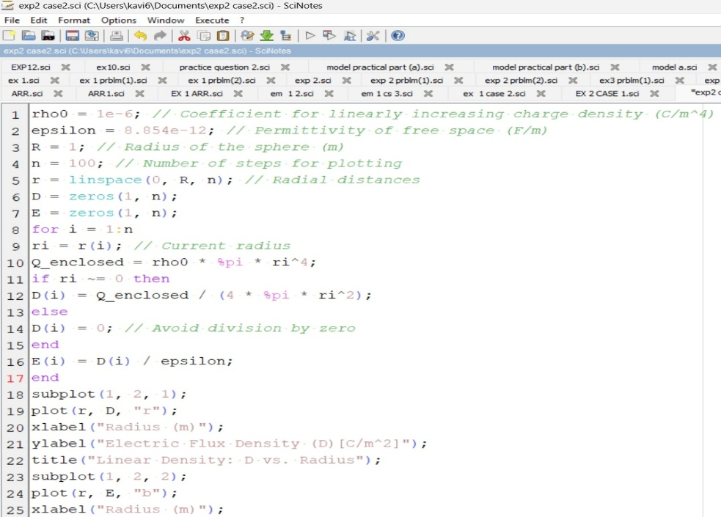
Output:
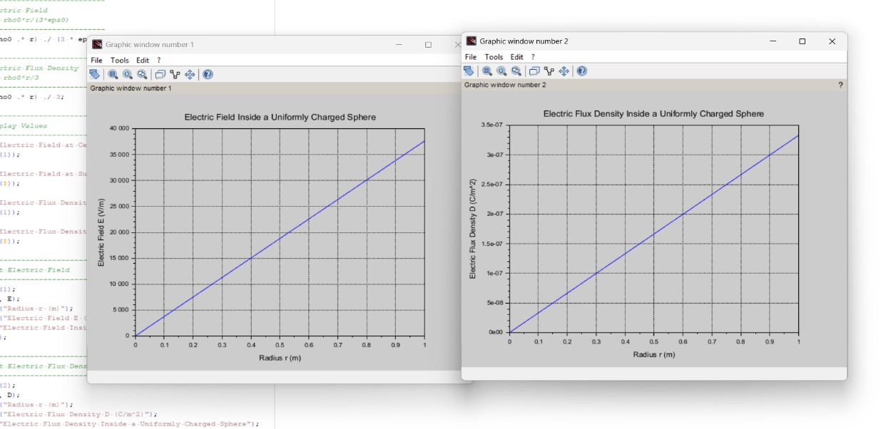
Case 2:
For a sphere with a linearly increasing charge density ρv=ρ0r.derive the expressions for the electric field (E) and electric flux density (D). Plot their variations inside the sphere and analyze the trends.
Code:
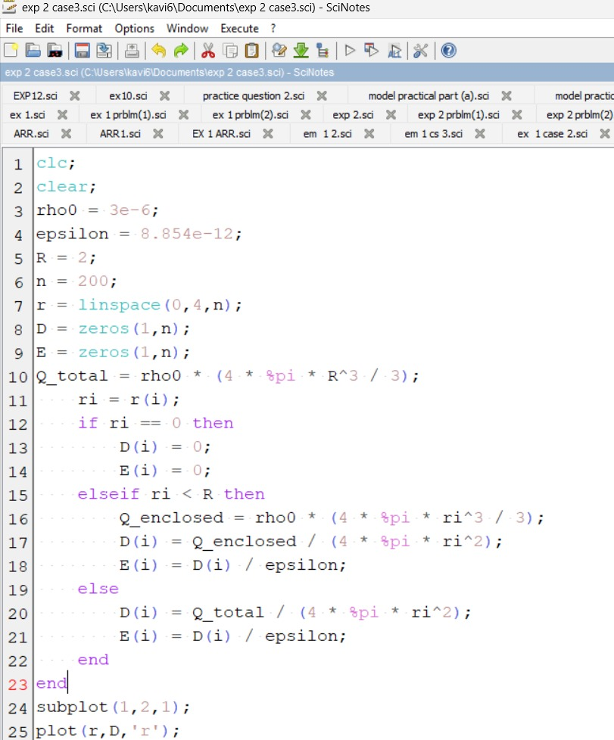
Output:

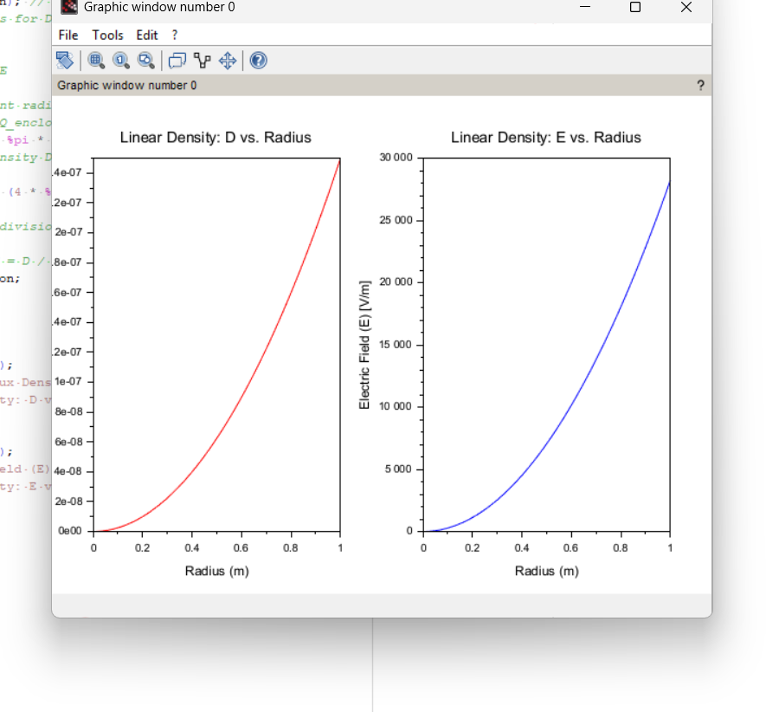

Case 3:
A sphere of radius R=2 m has a uniform charge density ρ=3×10^−6 C/m^3\
- Calculate and plot the electric flux density D(r) and electric field E(r) as a function of radial distance r, ranging from 0 to 4 meters.
- Discuss the behaviour of the electric field inside and outside the sphere.
Code: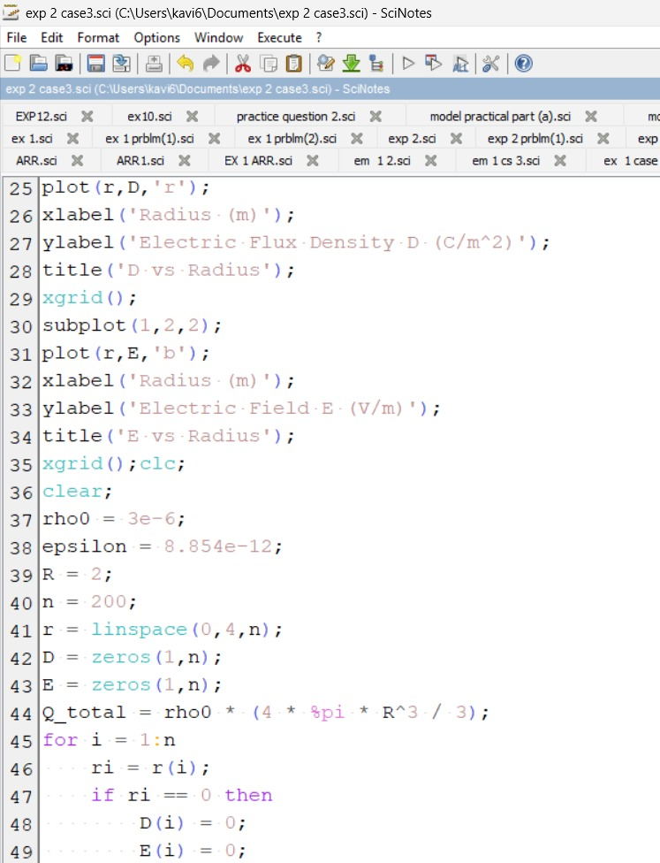
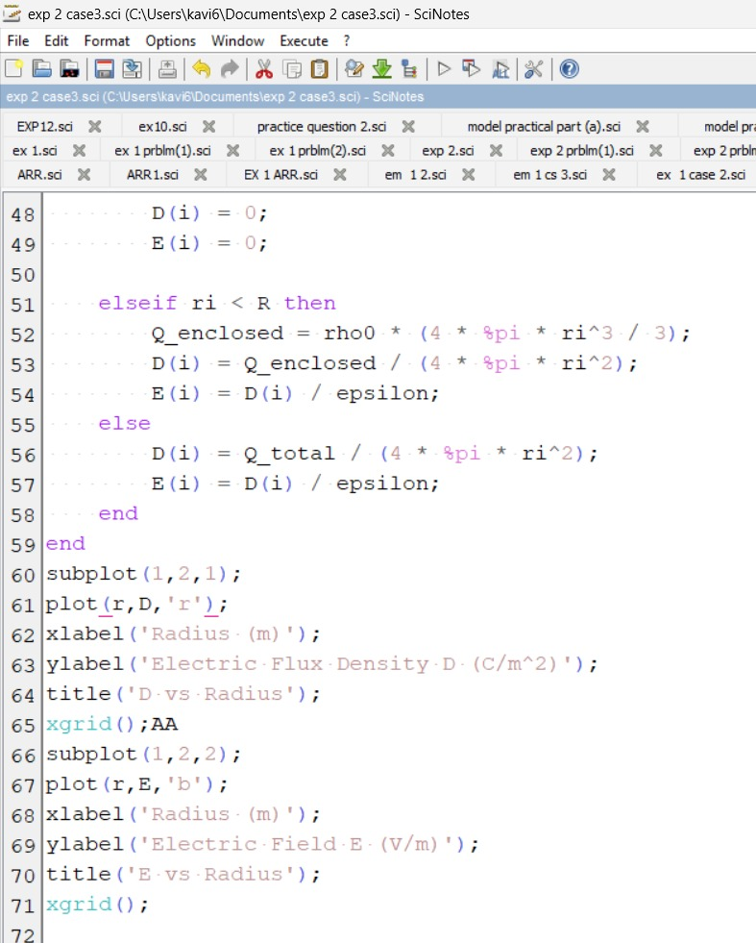
Output:
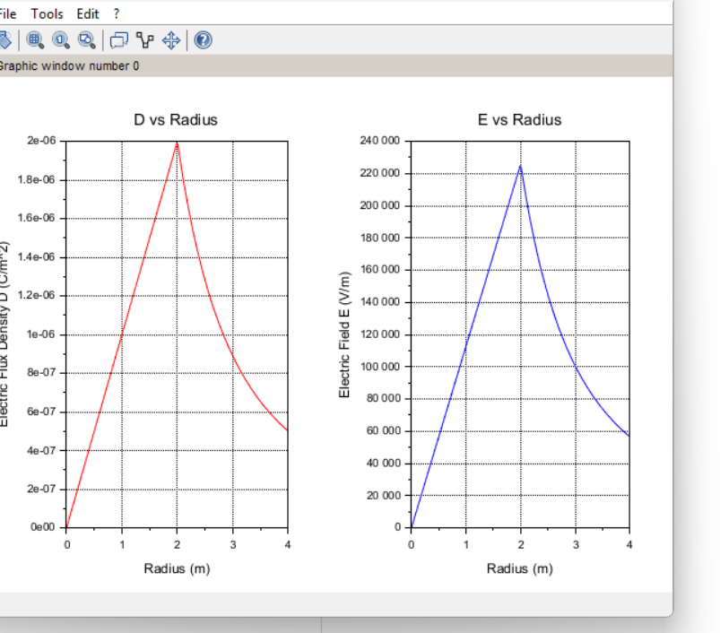

Result :
Thus the program was verified for electric field and electric flux density in sphere using SCILAB was successfully.

